The Northern Lights Chapter is starting a stock study group conducted by Chapter Directors and Volunteers. We plan on doing this study each quarter and posting our findings to our Chapter website at https://www.betterinvesting.org/chapters/northern-lights
My name is Barry Detloff and I will be leading this effort. You can reach me at detlo001@umn.edu if you have questions about our postings. This idea came from a Chapter member I and another Director met at this year’s BINC in Chicago. She mentioned that it would be helpful to see the process of selecting a company for one’s portfolio. These studies are for educational purposes only. Please do your own stock research. So, without further delay …
This study was initiated on June 25th, 2024. I like to start my study using Relative Strength. Relative Strength (RS) compares one thing against another to see which is stronger. There are two websites I use for this: finviz.com or stockcharts.com and both are free to use. You can subscribe to these to get more features and fewer ads but it is not necessary for our purpose. With stockcharts.com, you can go back and see RS in different time frames. What is nice about finviz.com is they get their data from Morningstar as does BetterInvesting so the Industry results you get from finviz match the Industries you will find at BetterInvesting.
Looking at finviz.com, I noticed the Financial Sector has done well. The Financial Sector is one of eleven sectors that make up our economy. Here is what I saw:
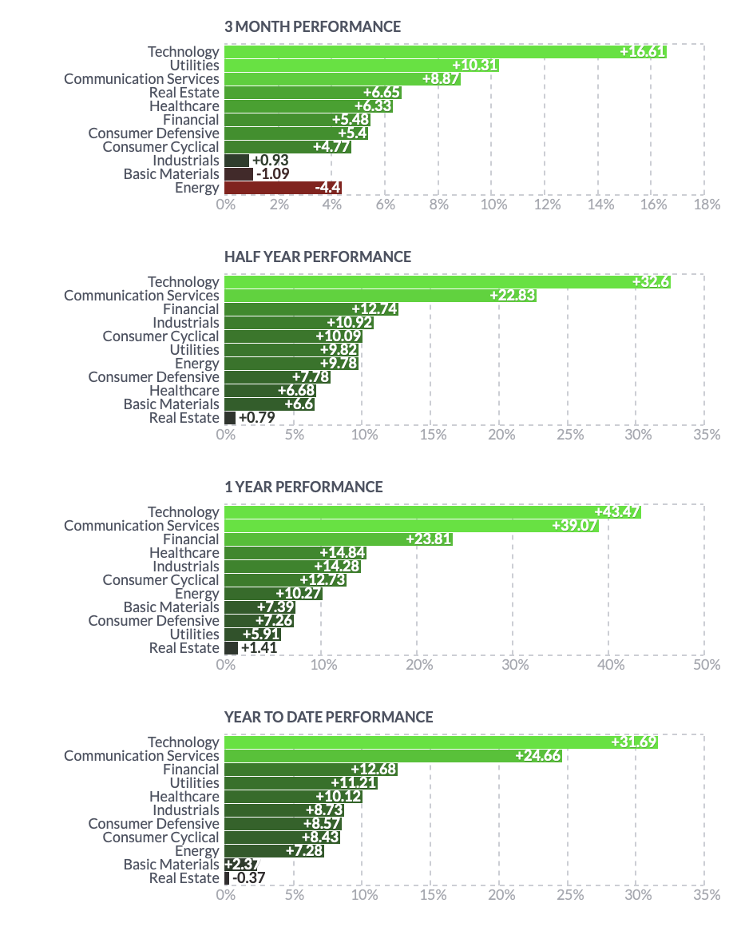
The Financial Sector is not the top one but it has performed well. This snapshot was taken on July 12th.
According to finviz.com, there are 15 Industries within the Financial Sector. Just like looking at which sectors are performing well, we can look at which industries have been doing well. Here is a snapshot also taken on July 12th.
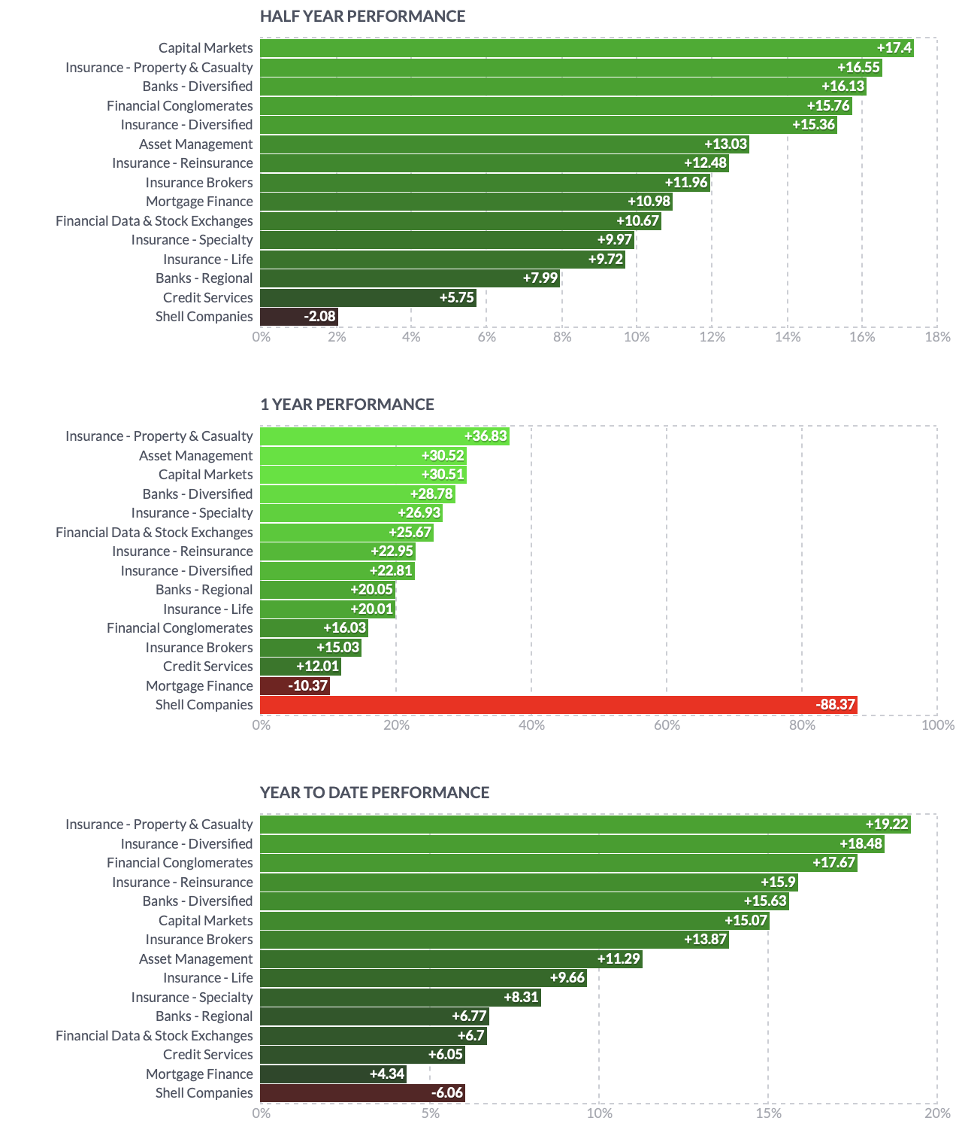
The Industry: Insurance – Property & Casualty is near the top in the above time frames. According to finviz.com, there are 39 companies in this industry. Using RS, we found a Sector and Industry that has done well recently. Now it is time to head over to BetterInvesting (BI) to look at these 39 companies.
My first step is to use BI’s stock screener and look at the Predefined Screen and see if any company is listed in the Financial Sector / Insurance – Property & Casualty Industry.
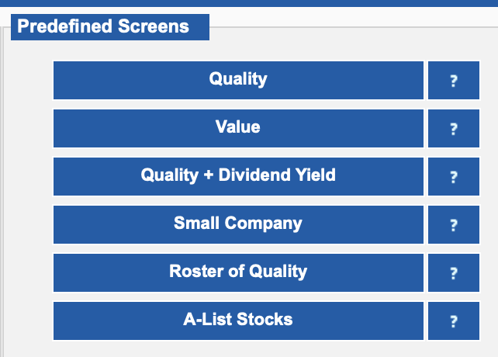
Click on Quality, sort the results by Sector, and look for companies in the Industry of interest. One company is listed: KNSL. Repeat this for each of the Predefined Screens. KNSL is also listed under Value, Roster of Quality, and A-List Stocks. Looks like we found a stock to study further.
Hovering my mouse over the company name on the SSG will give me information regarding the company size and a description of its business.
Looking at an SSG, my first make-or-break decision is whether the company is growing sales at the rate we expect for its size. Remember, a large-size company has annual sales of $10b or more and is expected to be growing sales between 5% to 8%. A medium-sized company has annual sales of $1B to $10B and is expected to be growing sales between 8% to 12%. A small-size company has annual sales of less than $1B and is expected to be growing sales 12% or more. KNSL is a medium-sized company and is growing sales by greater than 12%.
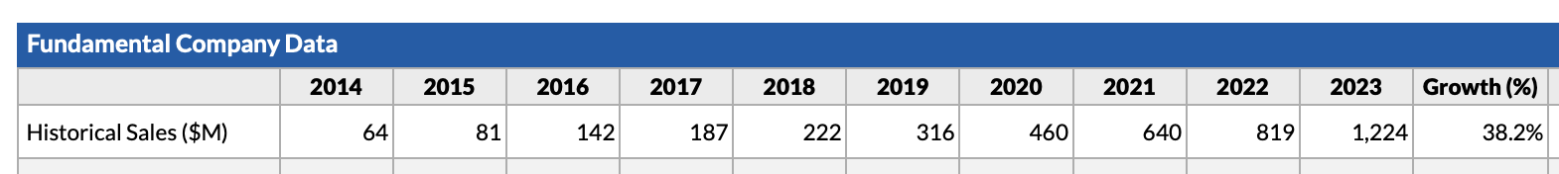
My next make-or-break decision is whether I see railroad tracks for Sales, PTP, and EPS. We like to see all three growing at the rate we expect or better and growing parallel to one another (railroad tracks). KNSL is doing this wonderfully.
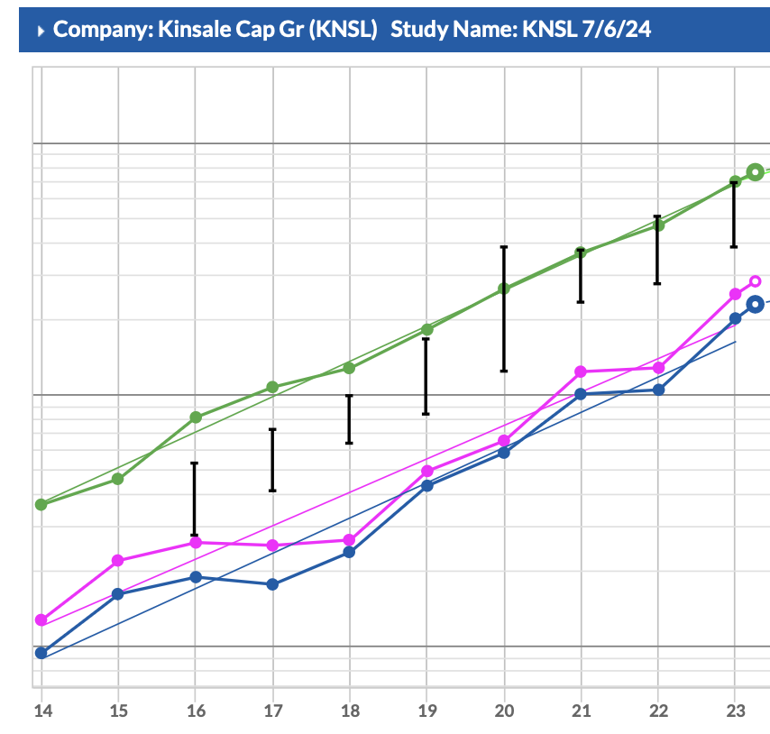
Forecasting Sales and EPS five-year growth can be a bit tricky. I use help from several sources including Value Line and finance.yahoo.com. Yahoo also uses Morningstar data so it will match BI. I like to be conservative with my judgments and hopefully be pleasantly surprised with the outcome. Using 12% growth for both Sales and EPS (remember – railroad tracks) is less than Value Line and Yahoo numbers.

Forecasting high and low prices is the next tricky part. I did remove the high PE from the years 2020 and 2022. I also removed the low PE from the years 2018 and 2022. It is nice that we can now see ten years of PE data in section three of the SSG. The current PE is 25.4 and I chose 25 as my high PE again trying to be conservative and pleasantly surprised by the outcome. In their May 31st, 2024 issue, Value Line has this: We also look for an expansion of the stock’s P/E multiple by 2027-2029, as we believe it will command an even higher premium relative to the broader market.

Five-year average low PE with those two years removed is 20.5 and I chose 20 as my forecasted low PE. These forecasts gave me a BUY rating with an Upside/Downside ratio of 3.5:1.

Now it is time to compare KNSL to its competitors. Remember, finviz.com had 39 companies listed in the Insurance – Property & Casualty Industry. BI has 40 companies because there are two ticker symbols for Donegal Group Inc. What I did was use the Preview Data button under Actions on BI’s screening tool and clicked on the Pin to save each of these companies to a Filtered List.
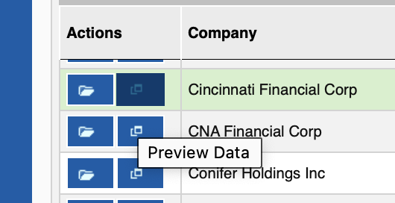
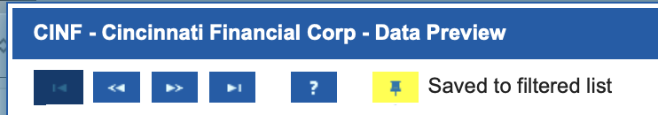
Once all 40 are in my filtered list, I click on Show Filtered Companies.
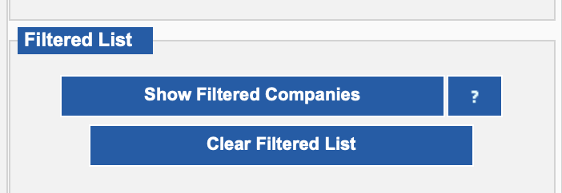
I sort by Size and look at Sales Growth. If it is not performing as we expect for a company of its size, it is removed from the list by clicking on the Preview Data button again and clicking on the pin to remove it. I ended up with 6 large, 6 medium, and 7 small-sized companies. I click again on Show Filtered Companies to refresh my list. Again, sort by size, look at Earnings Growth, and remove those not performing. I ended up with 3 large, 3 medium, and 3 small-sized companies. I click again on Show Filtered Companies to refresh my list. Now I look at EPS R2 and want to see numbers closer to 1. This means the EPS line is straighter showing more consistent growth for EPS. I ended up removing 2 small-size companies. I click again on Show Filtered Companies to refresh my list. This time I am looking at Morningstar’s Growth, Profit, and Financial Health grades. I give the A ratings a 4, B ratings a 3, C ratings a 2, and D ratings a 1. Each of the seven remaining companies gets an overall number. RLI has a 10, KNSL has a 9, CB, WRB, PLMR have an 8. These would be the four companies I would compare to KNSL. The last item I look at is the PE/Hist EPS column. Any number over 1 means the company may be overvalued. Only two companies as of July 12th were undervalued: KNSL and PLMR. Comparing the SSGs between these five companies, only KNSL is showing the up, straight, and parallel lines that we like to see.
Now the question is, would I buy KNSL on July 12th? I would not. Currently, KNSL is underperforming the S&P 500, its sector, and its industry as shown in the graph from stockcharts.com below:
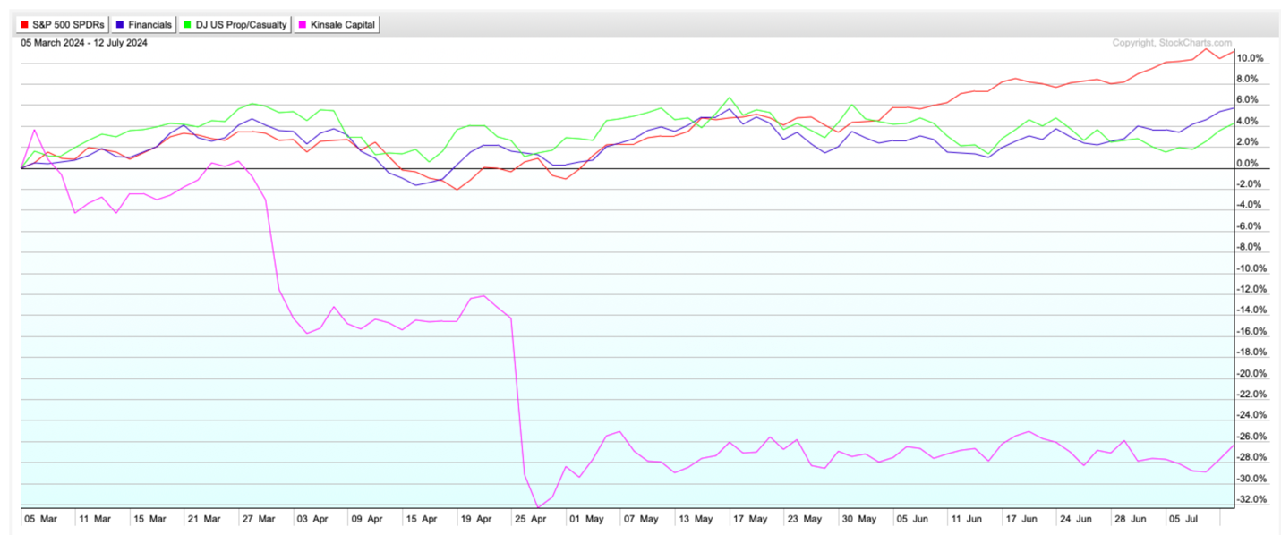
I would wait until I see some improvement in its stock chart like trading near its 200-day SMA. This would take it near the top of my BUY zone in the SSG.
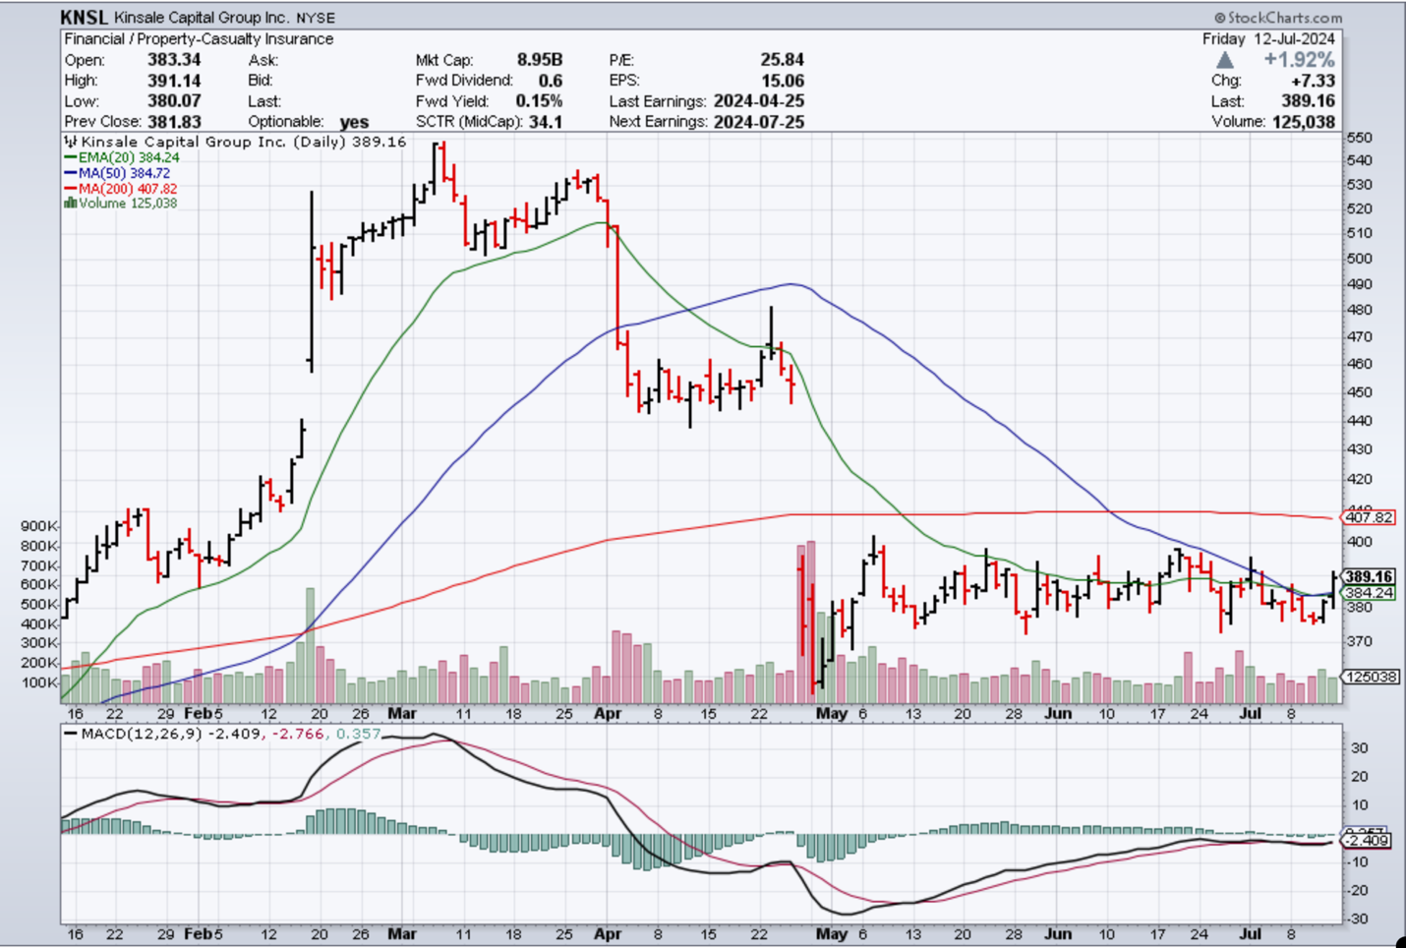

I hope this stock study is helpful. Remember to email me with questions.
Barry Detloff

